**Table of contents**

[SDLC (Software Development Life Cycle)](https://jayrapolu.hashnode.dev/intro-to-devops" \l "heading-sdlc-software-development-life-cycle)

[Waterfall](https://jayrapolu.hashnode.dev/intro-to-devops" \l "heading-waterfall)

[Agile Methodology](https://jayrapolu.hashnode.dev/intro-to-devops" \l "heading-agile-methodology)

[DevOps Methodology](https://jayrapolu.hashnode.dev/intro-to-devops" \l "heading-devops-methodology)

[Interview Best Answer for what is DevOps](https://jayrapolu.hashnode.dev/intro-to-devops" \l "heading-interview-best-answer-for-what-is-devops)

[Linux:](https://jayrapolu.hashnode.dev/intro-to-devops" \l "heading-linux)

* To Understand DevOps, we need to understand some concepts they are
  + SDLC
  + Waterfall
  + Agile

**SDLC (Software Development Life Cycle)**

* These are the phases or steps which are involved in the software development.
* These are the mandatory steps or common steps that everyone should follow while developing a software to achieve a quality product.
* Steps involved in this life cycle are:
  + Requirement Analysis
    - In this phase we need to understand the business requirements.
  + Planning
    - In this phase they will plan the pre-requisites, requirements and etc.,
  + Design
    - In this phase they will convert the General requirements to the technical requirements.
  + Implementation
    - In this phase developers will be writing or developing the code for the software.
  + Testing
    - In this phase the testers will test the software developed by the developers.
  + Deployment
    - In this phase the operations team will deploy the code to the production servers so the end users can access the application.
  + Maintenance
    - In this phase they will be doing security patches, updates, upgrades or adding new features etc.,

**Waterfall**

* In the starting of software evolution the companies used this Waterfall method to develop the software’s.
* First let us understand what Waterfall method is:
  + In Waterfall method the SDLC phases are followed step-by-step i.e.,
  + A diagram of a workflow

    AI-generated content may be incorrect.First team will do the requirement analysis, then it is handed over to planning team, after that planning team will hand over it to Design team with their inputs like this it will reach to the end team which is maintenance.
  + As you can see the process is flowing from top to bottom
  + but there are some disadvantages in this they are:
    - The requirements are fixed at the starting of the project and they can’t be changed until the project is completed.
    - There is a lot of time waste in the starting of the project and the team will be relaxed as there is so much of time.
    - only one team can work at a time and all other teams should wait for the previous team or previous phase to complete. so, the resource utilization is poor.
    - as testing is done after the full project development there might be a lot of defects or bugs in the project.
    - there might be some invalid bugs as well due to this there is a clash between developers and testers all the time.
    - The client might cancel the contract if he doesn’t like the product.
* To Overcome this defects or issues in the process they have introduced a new process which is:

**Agile Methodology**

* As we discussed to overcome the issues in the waterfall the agile process has been introduced, now let us understand what the agile Methodology is.
* Some Terminologies which you might see below are sprint, backlog and modules. let me explain those first.
  + Modules: The whole project is divided into some small development parts or blocks (e.g., Signup Page, Login Page, Cart, Home Page these are some individual module examples).
  + Sprint: It is nothing, but the number of days assigned to the team to complete the development, testing for one single module (e.g., If the Sprint is for 30 days the team should complete Signup Page within this first Sprint which is first 30 days which is Sprint 1, and they should start working on Login Page in next 30 days which we call as Sprint 2 and this will continue for all the modules).
  + Backlog: Backlog is nothing but if there are any defects or bugs in the Sprint 1 then this will be added to Sprint 2 along with Sprint 2 implementation.
* 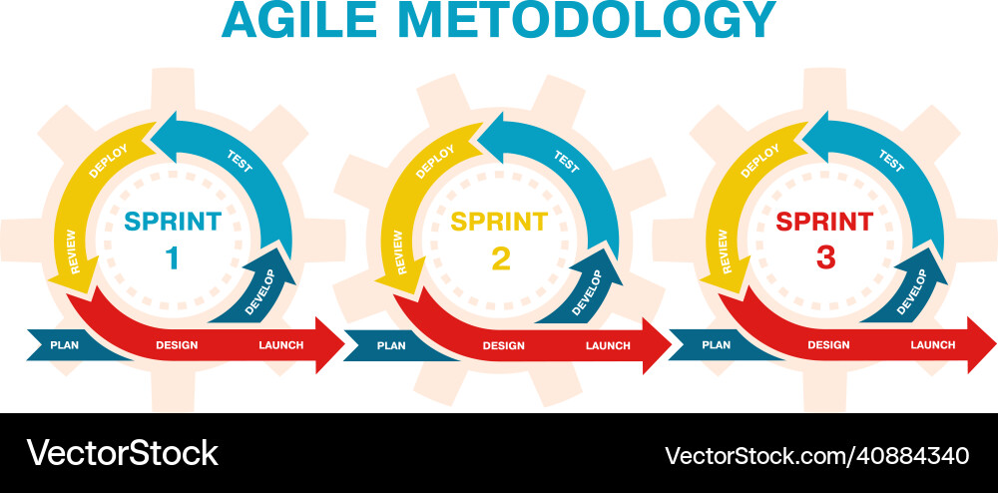

In Agile the whole product is divided into modules, and each module is developed in each sprint.

* If there are any defects or bugs in the Sprint those will be added to previous Sprint along with the new changes.
* but there as some disadvantages in this process as well, some of those are:
  + even though it is sprint based still the developers are working for first 15 days and the testing team is working for the last 15 days, the defects count is decreased when compared to waterfall but still there are some clashes between the development team and testing team as they are not working at the same time.
* To overcome this issue, they have introduced a new process or method which is:

**DevOps Methodology**

* DevOps is extension of agile we use the agile features as well in the DevOps
* In DevOps Process, if a developer is writing a code for a small feature for example a form for today then it will be tested by the testing team today itself once the developer has completed developing it and if there are any bugs it is reported back same day and will be fixed it on the same day or next day morning.
* by using this process, the count of bugs or defects are decreased mostly, and we were able to deliver a quality code without any defects.
* to achieve this, we will be using Continuous Integration, Continuous Deployment, Continuous Delivery.
* Continuous Integration:
  + In CI we will Automate the building and testing of the code written by the developer.
* Continuous Delivery:
  + In CD we will manually deploy the package to the environment servers.
* Continuous Deployment:
  + In CD we will Automate the deployment as well to the Environment servers.
* We will achieve all of this by automating every possible phase or task of SDLC.
* 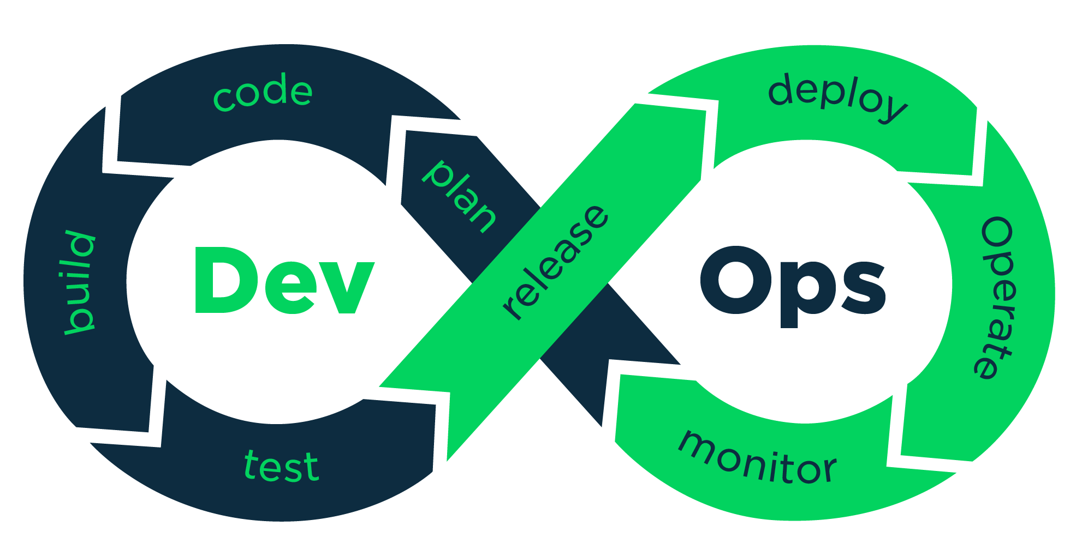
* Advantages:
  + Faster Releases with less defects.
  + better integration between the teams.
  + quality product outcome.
  + Immediate bug fixes etc.,
* There will be some Environments as well those are:
  + Dev, QA, SIT, UAT, PERF, PRE-PROD, PROD.
  + min we need to use 2 env which is dev and prod.
  + max we can use any number by increasing the environments we can achieve a quality product as testing is carried out in multiple environments.

**Interview Best Answer for what is DevOps**

* It is a process of building, testing and deploying the code written by the developer on the same day instead of doing this after complete development. we can achieve this using some continuous integration, continuous delivery and continuous deployment.
* we should use the automation mindset and automation tools to automate all the processes or phases which are involved in ci/cd/cd.

**Linux:**

* Linux is Invented by Linus Torvald’s in 1980’s.
* Before Linux we used to have Unix, which is nothing but a combination of software and hardware.
* so, there is less accessibility to the users, and they were not able to do customizations as per their taste.
* Linus implemented a new software from scratch with Unix principles using C language. which can be installed by purchasing the hardware of their choice.
* He also implemented the git to store all the source code.
* as it is open source the people can use the source code, and they can customize as they want and create an OS from it and install in their machines.
* So many Organizations have been already implemented their operating systems using their tweaks or customisations and we call them as distro’s or flavours.
* 99% of the usage will be same in all the distro’s, some commands might differ from distro to distro.
* Most of the Applications are serving or running on the Linux servers only there are some reasons for it, they are:
  + Light Weight (least size of linux os is 9mb)
  + open source
  + secure
  + huge community support
  + faster performance
  + regular updates/ upgrades
  + Easy to Setup / Install
  + Many More.